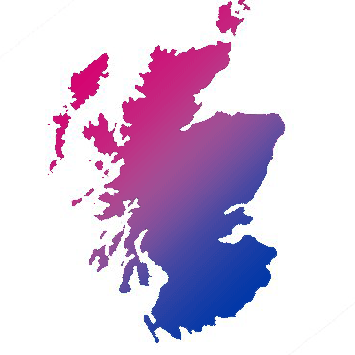

Scottish Bi+ Network

Application Form
Administrator

Please complete and return this form to recruitment@scottishbinet.org by 25/09/20 at 12pm BST. Late applications will not be considered. CVs will not be considered.
If you have any queries about this application form, or the role, please contact recruitment@scottishbinet.org

Personal Details
This part of the application will be kept separate when considering your application

Full Name:
Home Address:
Post Code:
Contact Number:
Email Address:

Are you eligible to work in the UK? Yes/No
When can you start work for us?
Do you consider yourself to have a disability? Yes/No
Please tell us if there are any ‘reasonable adjustments’ we can make to assist you in your application or with our recruitment process:

Are you interested in full-time (approx 24 hours per week) or part-time work?

If part-time, please state the hours, or range of hours, that you are looking to work:

If full-time, would you be willing to work part-time?

Experience & Qualifications

Relevant Experience

Please tell us about any relevant experience that you have for this role, it can be from current/previous employment, volunteering, or life experience.

Relevant Qualifications or Education

Please list any relevant qualifications or educational experience you have.

Any Other Information (Optional)

Please detail here any other information that you would like us to consider in support of your application.

I confirm that to the best of my knowledge the information I have provided on this form is correct and I accept that providing deliberately false information could result in my dismissal.
Name:
Signature: Date:

